Blackmore Primary School

School Information Report for children with Special Educational Needs and Disabilities (SEND), April 2026

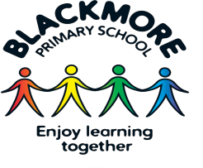 | The Special educational needs and disability code of practice refers to SEN as ‘having a learning difficulty or disability which calls for special educational provision to be made, has a learning difficulty or disability if they have a significantly greater difficulty in learning than the majority of others of the same age or has a disability which prevents or hinders him or her from making use of facilities of a kind generally provided for others of the same age in mainstream schools.’  Special Educational Needs and Disabilities (SEND) provision can be considered as falling under four broad areas, as defined in the SEN Code of Practice (2015):  1. Communication and interaction  2. Cognition and learning  3. Social, mental and emotional health  4. Sensory and/or physical  At Blackmore Primary School we are committed to working in partnership with our pupils, families and external agencies to identify and support children’s needs.
Mission statement  Our school’s Core Values are the foundation to all policies and procedures.  Our Core Values  Be the best you can be  Respect  Independence Generosity Honesty Tolerance  Enjoy learning Together Responsibility | At Blackmore Primary School we believe that learning for all children, regardless of their needs, deserves a curriculum that is enjoyable, engaging, inspiring and motivating.  Rooted in our core values, our SEND provision ensures that our pupils thrive academically, socially, physically and emotionally.  We aim to…  - Provide an engaging and balanced cross curricular education for all children, which nurtures and embraces all children’s interests and potential, within a safe, secure and happy environment.  - Inspire children to become life-long learners and responsible citizens who give of their best and are equipped with the skills to prepare them for their futures.  - Have high expectations of behaviour, attitude, manners, standard of presentation and attendance.  - Ensure that all those involved in the school community demonstrate the Core Values towards one another and that they enjoy learning and working together.  We also aim to promote positive learning for our children with SEND through…  - Ensuring they feel a valued part of the school community  - Providing a safe and supportive environment  - Having access to a range of teaching and learning strategies to suit their needs  - Promoting independence and resilience as a learner, without over-reliance on adult support  - Identifying and addressing their needs as quickly as possible  - Working in partnership with families to support their children  - Making effective use of all support services available to us wherever possible.  We value the contributions made by all children, families and professionals to help enhance and maintain our inclusive school community.
Admissions Policy | All school admissions are dealt with by Essex County Council. Please use the guidance provided by the council to apply for your child’s school place. This information can be found on Essex County Council’s admissions page: Admissions | Essex County Council  School places are allocated based on the following criteria:  - Looked-after children and or exceptional medical circumstances  - Children with a sibling attending the school  - Children living in the priority admission area.  - Remaining applications  In the event of over subscription within any of the above criteria, priority will be determined by straight line distance from home to school, those living closest being given the highest priority.  Our admissions policy can be found on the school website: Blackmore Primary School - Admission Arrangements
Who is the School’s SENDCo? | Blackmore Primary School is a mainstream school which fosters an inclusive ethos. SEND provision is high on the school’s agenda. Our school’s SENDCo is Miss Bellamy; she works Mondays and Tuesday mornings. Miss Bellamy can be contacted via the school office on 01277 821528 or by email parents@blackmore.essex.sch.uk.  Our SENDCo is fully supported by the Senior Leadership Team and works closely with the Headteacher, class teachers and wider school staff to ensure that there is a whole school approach to SEN provision.  Our schools SEND link governor is Mrs Deborah Moppet. She can be contacted via the school office parents@blackmore.essex.sch.uk
How do you identify and assess pupils with SEND? | At Blackmore Primary School, we aim to deliver inclusive high-quality teaching to all our pupils. It is the role of all staff to ensure that children with SEND play a full role in the life of the school and can meet their best potential.  All children are assessed as part of daily teaching and learning, through observation and marking and feedback. Children’s progress is closely tracked on our school SOFAN tracking system which provides class teachers, subject leaders and senior leaders with an overview of progress and levels of attainment for each child in all curriculum subjects. Pupil progress meetings are held termly with the Headteacher and Deputy Headteacher, identifying any children who are making less than expected progress in their learning or for any reason are demonstrating a cause for concern across the four broad areas.  The identification of SEN is built into the overall approach of monitoring the progress and development of all pupils. Where pupils are making inadequate progress given their age and starting points teachers will take action to remove barriers to their learning. The pupil’s response to such support may help identify their needs. Class teachers monitor the progress of all pupils carefully and consult with the Headteacher and SENDCo if a child continues to make less than expected progress.  Where it is decided that a pupil requires SEN support, they will be added to the schools SEND register. We will work in partnership with the family through a process called ‘one planning’. The school follows a graduated approach to SEND provision and support, involving an ongoing four-part cycle of ‘assess – plan – do – review.’  Visual Summary of One Planning  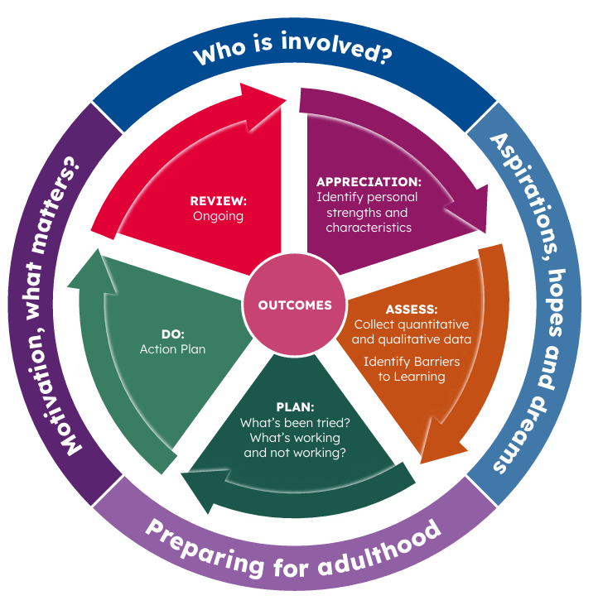  As part of the assess stage, various sources of information are important. These include:  - teacher assessments  - observations and knowledge of the child  - pupil progress, attainment and behaviour records  - the views and experiences of the family  - the pupil’s own views  - where appropriate, advice from external support service  The SENDCo, in consultation with the family, may request the Local Authority (LA) to initiate a statutory EHCPNA (Education Health Care Plan Needs Assessment) of a child if:  - Adequate progress has not been made, despite intervention and SEN support  - A child is identified as demonstrating a significant cause for concern  - If the child’s needs cannot be met under the current resources available to the school.  The Local Authority are responsible for carrying out an EHC assessment and they will decide whether the child needs an Education Health Care Plan (EHCP). The purpose of an EHCP is to meet the special educational needs of the pupil to secure the best possible outcomes for them across education, health and social care.
How does Blackmore Primary School adapt the curriculum and the environment? | Formative and summative assessment, along with careful monitoring of pupils’ progress allows teachers to plan, tailor and deliver differentiated lessons and interventions.  At Blackmore Primary School we use a selection of reasonable adjustments and strategies, following the graduated approach, to support children with SEND. This may include:  - Visual aids (this may include a visual timetable, visual task support, coloured overlays)  - Sensory aids (this may include ear defenders, loop ear plugs, a wobble cushion, physical sensory tools to aid listening)  - Physical supportive aids (this may include a multisensory approach to learning)  - Speech and Language sessions (this may include delivery from school staff or external NELFT professionals)  - Targeted small group interventions (this may include curriculum focused interventions or emotional well-being interventions)  - Targeted individual interventions (this may include curriculum focused interventions or emotional well-being interventions)  - Individual work stations in the classroom (where deemed appropriate by the class teacher)  - Assistive technology during the school day (this may include a recording device to support writing tasks)  - Adjustment to the school timetable (this may include transitional support, timed sensory breaks)  - Adjustment to homework expectations (where deemed appropriate by the class teacher)  We work in partnership with our families and value their contributions, helping us to know our pupils well. If we require further support or advice concerned with a pupil’s provision, the school’s SENDCo may consult with the school’s Inclusion Partner (IP) or Link Education Psychologist (EP).  As a school, we are not able to make any formal diagnosis. The school’s SENDCo will support families to make external referrals or consult with external agencies where appropriate.  More information about our school’s curriculum can be found here: Blackmore Primary School - Curriculum
What are the arrangements for supporting emotional and social development? | At Blackmore Primary School we have adopted the values of the Essex Approach to understanding behaviour and supporting emotional wellbeing known as Trauma Perceptive Practice (TPP). It’s approach is underpinned by the themes; • Compassion and Kindness • Hope • Connection and Belonging.  Zones of Regulation underpins our whole school approach to helping children to understand and express their emotions and the importance of self-regulation. It’s approach groups feelings and levels of alertness into coloured zones. We believe that teaching children to self-regulate and manage their feelings will lead to increasing happiness, readiness to learn and effective personal and social skills that they will carry through life. More information about this approach can be found here: Blackmore Primary School - Zones of Regulation  We are highly attentive to our pupils’ social and emotional needs and we are committed to understanding each  individual and responding effectively. Our staff recognise and respond supportively to pupils, providing compassionate support to help pupils feel safe, understood and regulated. We tailor our approach to pupils’ individual needs, using reasonable adjustments in the classroom and supportive measures, such as personalised regulation plans or behaviour support plans where necessary.  Every class follows a mindful structured PSHE (Personal, Social and Health Education) curriculum, which brings together Personal, Social, Health Education, Emotional literacy, Social skills and Spiritual development in a comprehensive scheme of learning that is taught weekly in classrooms. More information about our PSHE curriculum can be found here: Blackmore Primary School - PSHE  Where appropriate and in consultation with a pupil’s family, the school’s Headteacher and SENDCo will make a referral to extended agencies to seek support from services, such as Kids Inspire, CAMHS, Virtual Schools or the Essex family and wellbeing service. We welcome the opportunity to work collaboratively with these services and are happy to accommodate their therapeutic support in school.  We value the importance of mindfulness in supporting children’s emotional wellbeing and self-regulation. For this reason, we offer mindfulness intervention, delivered by a trained mindfulness practitioner, as well as a mindfulness after-school extracurricular club.  We have a positive approach to managing behaviour and inspiring achievement. More information about our school’s behaviour and relationships policy can be found here: Blackmore Primary School - Policies
What are the arrangements for consulting parents of pupils with SEND? | We are committed to working in partnership with our parents to ensure that they feel well informed about their child’s learning and progress.  Parents are invited to termly one planning meetings to discuss and share their child’s learning, achievements and next steps. Prior to these meetings class teachers and the SENDCo liaise to discuss a pupil’s progress and next steps.  One planning meetings take place with the class teacher, and where appropriate the child too. The child’s provision plan is shared, with a discussion focused on the child’s next steps and support strategies—including reasonable adjustments and interventions in place to help the child progress to their next steps.  We value working collaboratively with our families during one planning meetings and provide support where needed. Together we set an achievable home-school target, so that families can help their children to reach their potential too.  Class teachers, in liaison with the school’s SENDCo, will ensure that parents receive a copy of any relevant documentation associated with their child’s SEN provision.  If your child has an Education Health Care Plan (EHCP) you will be invited to one planning meetings with the class teacher and the school’s SENDCo, as well as an annual review meeting each year.
How can I let the school know that I am concerned about my child’s progress? | If you have concerns about your child’s progress, you should speak to your child’s class teacher initially. Our class teachers can be contacted via the school office at parents@blackmore.essex.sch.uk. Our Class teachers work very closely with the SENDCo.  If your concerns continue, parents are welcome to request an appointment with their child’s class teacher and the SENDCo via the school office at parents@blackmore.essex.sch.uk.
How can I make a complaint? | The process for school related complaints can be found here: Blackmore Primary School - Policies
How is additional support allocated to children? | The total school budget received from the Essex Local Authority includes money for supporting children with SEND.  The Headteacher, in consultation with the school governing body and the school’s SENDCo, determines the allocation of the SEND budget. The money is used to provide additional and supporting resources determined by the needs of the school.
What are the  school’s transition arrangements? | We strive to ensure a smooth transition for pupils between each Primary School Phase including:  - Pre-school and Reception class,  - EYFS and Key Stage 1,  -Key Stage 1 and Key Stage 2,  - Year 6 to Year 7  -And during a school academic year where a pupil may join or leave the school  We understand that children may feel vulnerable during each stage of transition, so we work closely with families and where appropriate put in place a variety of strategies that support a smooth and positive transition experience.  Please see our Transition Policy located on the school website for further information about transition to school: Blackmore Primary School - Policies
The Brighter Hub | Our Brighter Hub offers a provision for key stage 1 children during the school day. Considerable adjustments are made to meet the specific needs of pupils.
Where can parents find information on the school’s local offer and other support services? | Blackmore Primary School supports the Local Authority’s Local Offer. The Local Offer is a very helpful resource for parents. It provides support in understanding the range of services available for SEND in the local area. For more information on Essex Local Authority’s Local Offer please visit their website on Essex County Council: Special Educational Needs and Disabilities (SEND) | Essex Local Offer  Essex SEND Local Offer Roadshows These are events for parents and carers of children and young people with SEND. To find out more about when the next SEND roadshow is, please visit: Essex SEND Local Offer Roadshows | Essex Local Offer  Other local support services which you may find useful  CAMHS supports families with the NHS services available for mental health. YoungMinds | Mental Health Charity For Children And Young People | YoungMinds  Essex SEND IASS (Special Educational Needs and Disability Information, Advice and Support Service) - provides free, confidential and impartial information, advice and support about Special Educational Needs and Disability (SEND) for children and young people: Essex SEND - Information, Advice and Support Service  Essex Child and Family Wellbeing Service support children and families to improve their health and well-being. They provide a ‘family hub’, which consists of a variety of specialist practitioners: Home - Essex Child and Family (South Essex: 0300 247 0013)  Families In Focus are a charity working with families who have a child with SEND on how to access appropriate education and social care. Home - Families InFocus Essex  Kids Inspire is a mental health charity offering mental health support, including trauma support, to families. A children's mental health charity | Essex and Suffolk  NELFT provide the community health care services for Brentwood. This includes occupational therapy, speech and language services and community pediatric service: Brentwood | NELFT NHS Foundation Trust  SNAP are a registered charity that provide support for families whose children have additional needs or disabilities. SNAP Charity - Registered Charity No.1077787  SPACE provide advice and guidance, including one to one support and online group sessions, to parents and carers Home | Support for Parents And Carers in Essex

