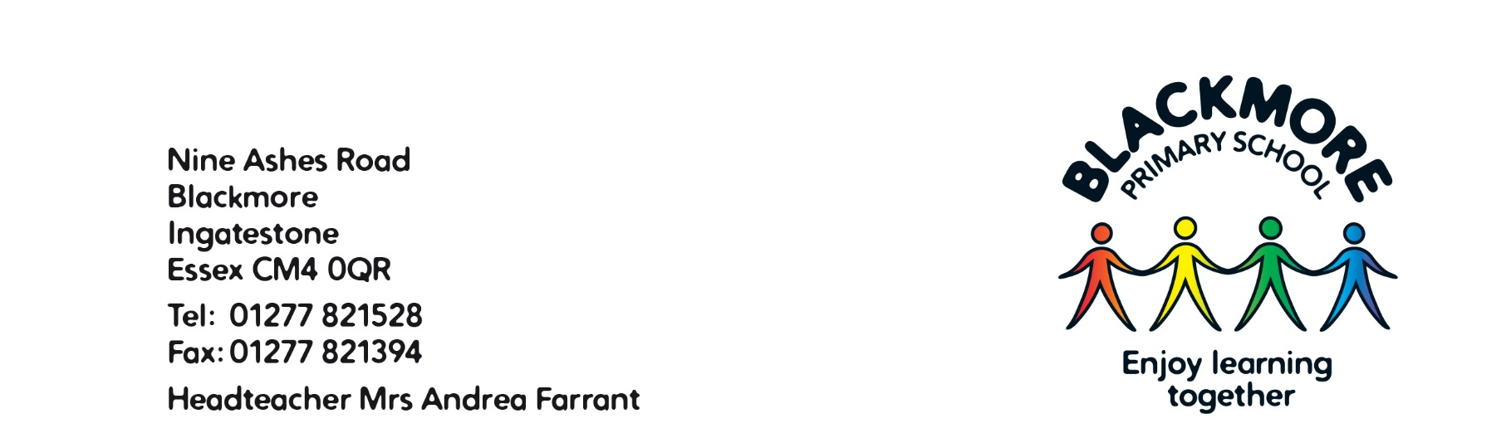

September 2024
Dear Parents and Carers,

Welcome back to school for the Autumn Term. It was lovely to welcome the pupils into Class Three last week and we hope you had a wonderful summer break.
Curriculum
Our topic this term is Volcanos. The children will be exploring ‘Why do people live near volcanoes?’ then we will be learning about ‘What do some of the Ancient Civilisations have in common? In Science, we’re investigating Rocks and Soils and then Light and Shadow. In PSHE we will be following the Jigsaw scheme and focussing on ‘Being Me in My World’ this half term and ‘Celebrating Difference’ after half term. We will be starting Spanish lessons now they are in Key Stage 2.
Keep an eye on the Class Pages on the website for more information about the Curriculum Overview for the year.
PE
This term, PE is on a Monday, and PE kit needs to be in school at all times. Please ensure the pupils can take out their own earrings, and please provide them with a small, named pot to put them in to keep them safe. If they are not able to take them out themselves, then please remove them on Mondays and Thursdays, in-line with Essex County Council policy. When the weather begins to get cooler, and pupils start to wear tights, please pop a pair of socks in the PE bag to wear when they change.
Swimming lessons are on Thursdays this half term, so please ensure the pupils are in class promptly on Fridays with their swimming kit.
Reading
Children are getting into the habit of putting their reading book into a box when they arrive in the morning: one for books that need to be changed and the other for books they’re still reading. Please ensure their reading book and record is in school every day. Remember to write up in their record when you have heard them read a book. Children are expected to read at least 3 times a week and we these will be checked and awarded house points on a Monday.
Homework
In addition to reading, Homework will be set on a Thursday and is to be returned by the following week. This will usually a spelling activity and at times a Maths, an English task, a Science or Topic based activity.
Spellings can be access weekly, on Spelling Shed, in addition to the list and activities in your books. Spellings will be checked the following Thursday, please find the dates on the spelling sheet. We will be looking for the correct spellings being used in their work, not just the score on Wednesdays.
Times Tables can be practiced on Times Table Rockstars, but we encourage your child to practice these in a way that they find fun and helpful.
Snacks
As the class are now in KS2, fruit is no longer provided, so please send the children in with a healthy snack in their book bag, in-line with the lunchbox/snack policy on the website. Alternatively, they can bring in money for the tuck shop in a named purse/wallet.
Please ensure everything is named for your child. Multiple water-bottles or jumpers, for example, are easier to return when they are named.
If you have any questions or concerns, please do not hesitate to get in contact with me through the email address parents@blackmore.essex.sch.uk and I will do my best to offer any support or advice.
After School Collection Arrangements
Please could you send in a new form, which can be downloaded from the website, to ensure we have accurate and up-to-date contact numbers and names. Thank you.
I am really looking forward to getting to know the class and working with them this year.

Yours sincerely
Miss E Watson
Class 3 Teacher

